**Raspberry Pi 4 setup**

**Reference guide used:** https://crosstalksolutions.com/getting-started-with-raspberry-pi-4/

This guide will allow you to get a very basic operating system (Raspbian) up and running on the Raspberry Pi 4. This guide is for using the microSD card pre-installed with NOOBS which allows the user to skip installing the operating system on SD card before usage.

**Step 1: Initial Setup**

Place the Raspberry Pi in its designated cover and add the heat sinks where suitable. Insert the microSD card (preinstalled with NOOBS), HDMI, keyboard, mouse and power into the pi as shown in the given ports. You can connect the pi to Wi-Fi when NOOBS first boots up.

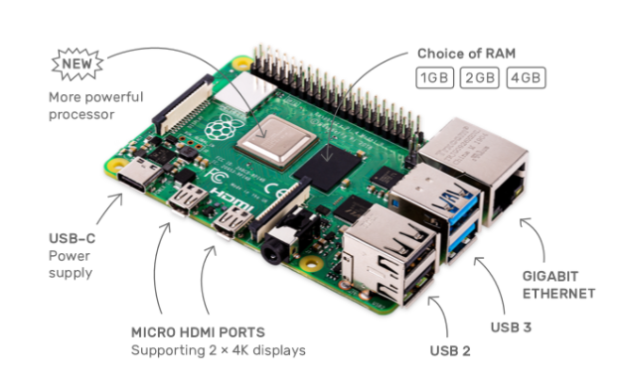

**Step 2: Install Raspbian**

At first boot up, the following screen will be shown in the monitor the pi is connected to. Connect the pi to a wireless network by selecting “Wifi networks” as shown below:

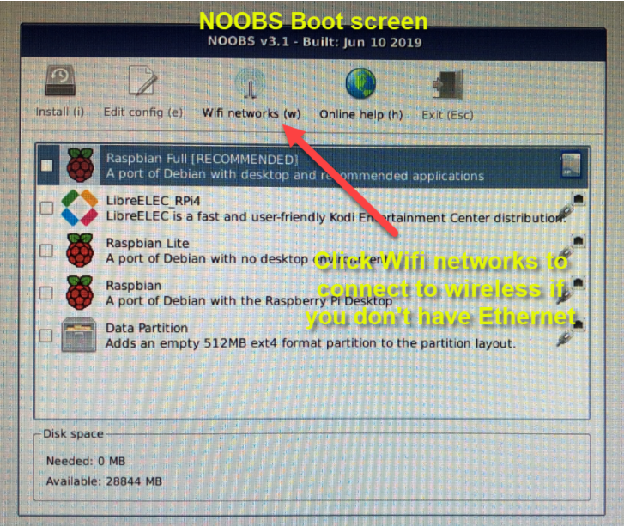

After connecting to Wi-Fi, check the box next to ‘Raspbian Full’ and then click ‘Install.’ You will be asked if you are sure you want to do the selected OS, click ‘Yes.’ Raspbian will now install.

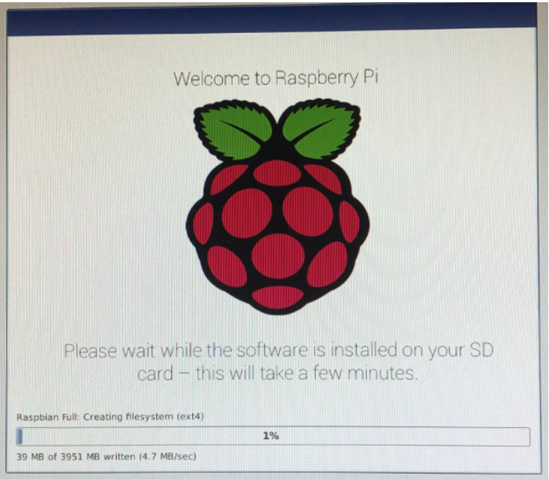

After the installation has finished, click OK and your Raspberry Pi will reboot. Upon first booting up, you will receive a welcome screen and startup wizard. Your IP address will show on this screen, take note of it. Click ‘Next’ to start the wizard.

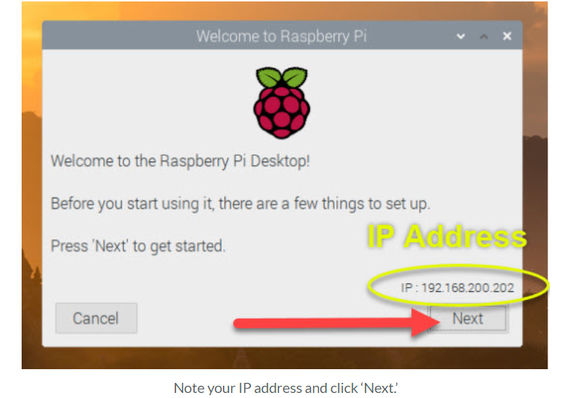

The first step of the wizard requires you to enter your country and time zone. Fill out the information and then click ‘Next.’

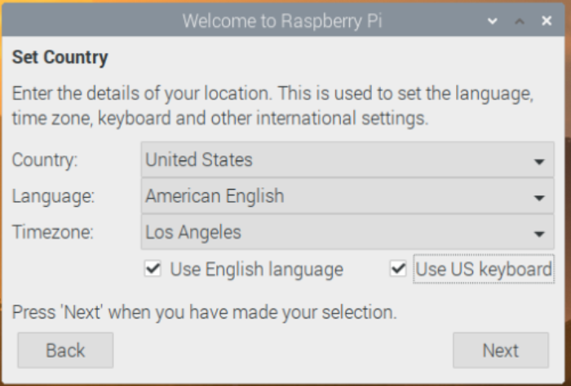

Next, change and enter a strong password for you “pi” user and click ‘Next’ when finished.

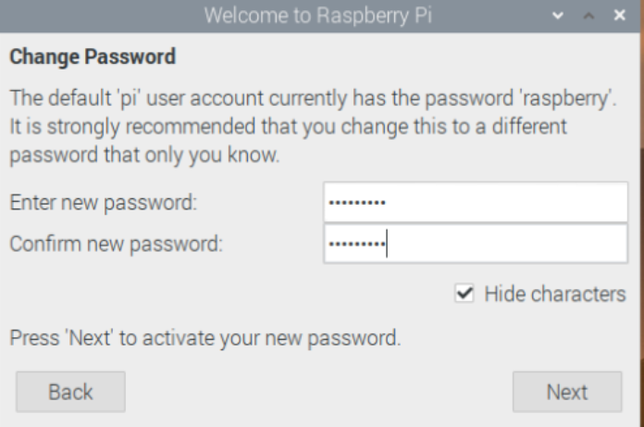

To connect to a wireless network, choose your network from the list, enter the password, and then click ‘Next.’ Otherwise, you can click ‘Skip’ if you do not want to connect to a wireless network.

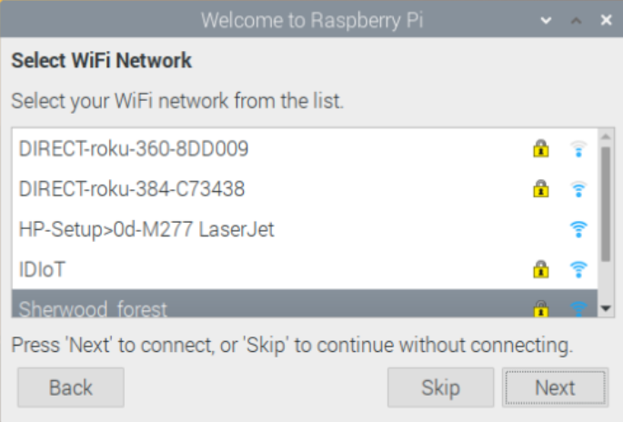

Update the software by clicking “Next”.

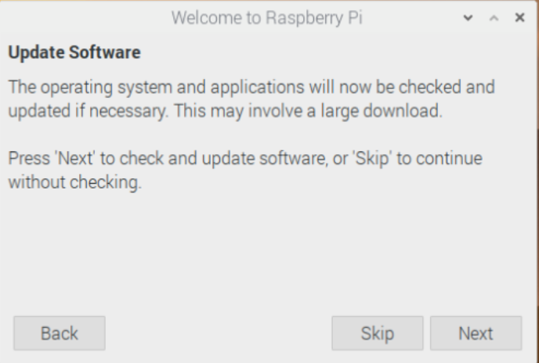

Click “Restart” to restart the Raspberry Pi:

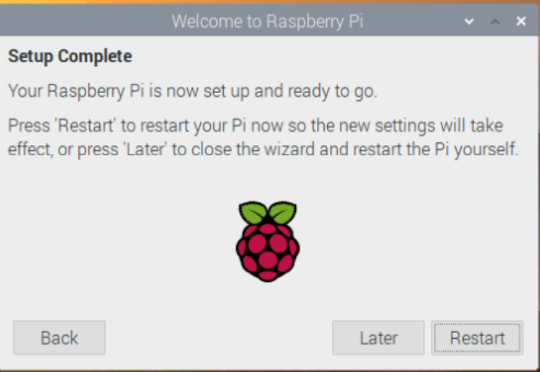

**Step 3: Updating the software**

After the Pi has rebooted and came back online, we can manually update the software. Open a terminal window by clicking on the Terminal icon in the upper left-hand corner or press CTRL+ALT+T:

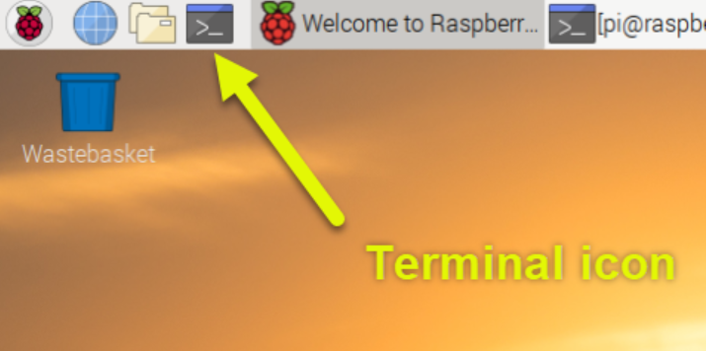

Run the following command in the command terminal:

sudo apt-get update && sudo apt-get upgrade -y

**Step 4: Raspberry Pi Configuration and Remote Access:**

On the Raspberry Pi, we can enable remote SSH and VNC connectivity to make usage of the Pi easier. To open Raspberry Pi configurations, click the Raspberry Pi icon in the upper left-hand corner and choose “Preferences” and then “Raspberry Pi Configuration”:

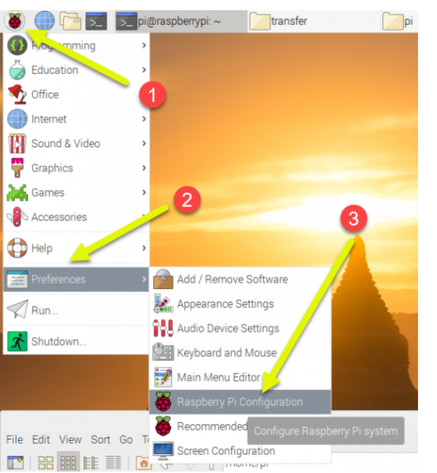

Uncheck the box to enable username and password to log in for increased security measures:

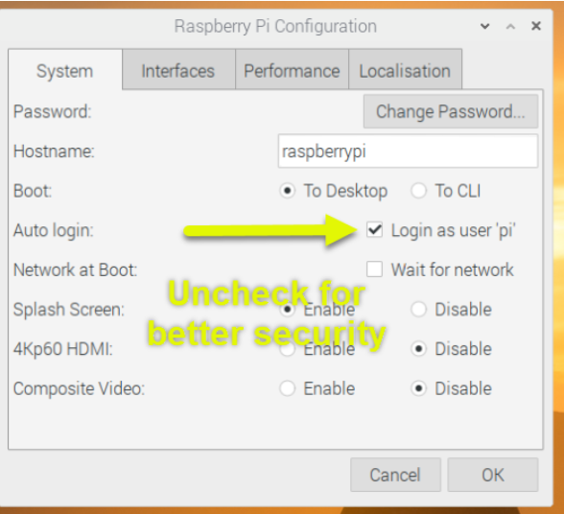

Click on the Interfaces tab and select ‘Enable next to SSH and VNC. SSH will allow us remote CLI access to the Raspberry Pi, and VNC will allow us to open a remote desktop using [VNC Viewer](https://www.realvnc.com/en/connect/download/viewer/). Then, click OK to finish.

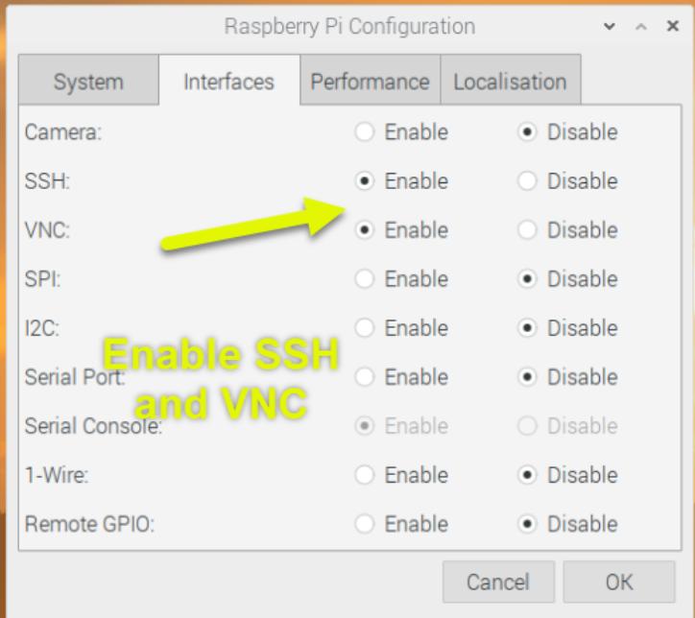

Reboot the Raspberry Pi to make sure the new changes are taken into effect.

To view the Raspberry Pi desktop view on your own PC, first download VNC Viewer and install it on your PC. Run the VNC viewer and choose CTRL+N to create a new connection.

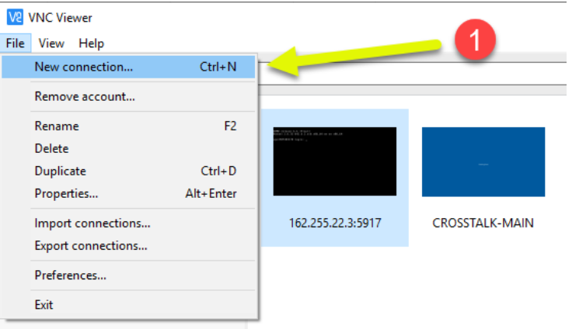

For VNC Server, enter the IP address of your Raspberry Pi. For the Name, enter in a friendly name for the connection. Then, click OK.

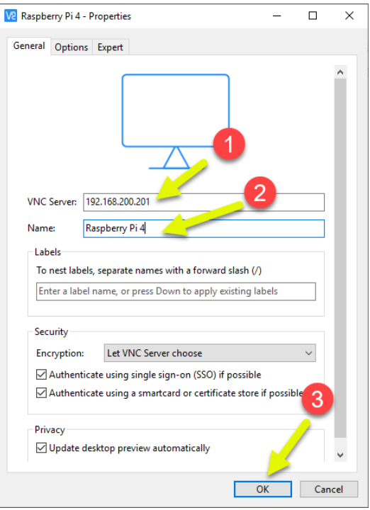

Double-click your new VNC connection and you will be prompted for a password. Use ‘pi’ as the username and the password that you set in the setup wizard.

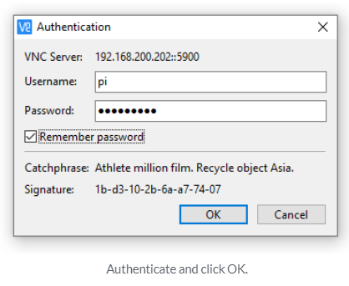

You should now be connected to you Raspberry Pi desktop screen:

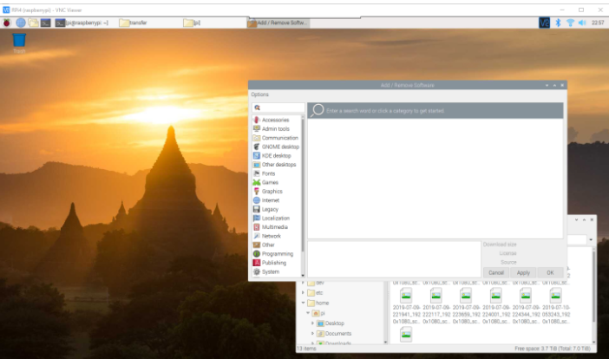

**NOTE:**

VNC viewer only will work if your Raspberry Pi is connected to a network (Wi-Fi) that will allow the IP address of the Raspberry Pi to be public. Also, make sure that both the laptop with VNC viewer and the Raspberry Pi are connected to the same network to ensure that VNC viewer works. Use “ifconfig” in the terminal window of the pi to view the IP address of the pi.